Question1

For this question, I first simulate the normal distribution and t-distribution based on the original data. Then, I calculate the VaR and CVaR value for empirical data, normal distribution data, and t-distribution data.

The math formula that I used:

The functions that I wrote:

The result that I get:

The plot that I draw:

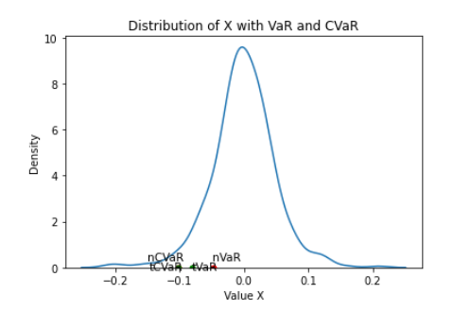

Question2

All my functions already added in my notebook file.

Question3

First, I separated the portfolio into three portfolio.

Then, I calculate the weights for each portfolio:

Then, I applied the weights onto portfolio price to calculate the portfolio total value for each days

Then, I calculate the rate of returns for each portfolio

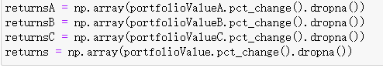

The result that I get:

